Operators & Control Flow

- Operators
- Block Scope
- Conditional Statements
- Loops
- Determinate Loops
- Multiple Selections with switch
- Statements That Break Control Flow

- Operators
In programming, operators are the decision-making tools that allow a program to calculate, compare, and control values. Just like mathematical symbols guide humans in solving problems, Java operators guide the computer in performing operations and making logical decisions.
When a program receives data, operators determine how that data should be processed. They can perform calculations, compare conditions, combine multiple expressions, and control the flow of a program. Understanding operators is essential because almost every Java program depends on them to transform input into meaningful output.
Operators are special symbols or keywords in Java that are used to perform operations on variables and values. They allow programmers to combine, modify, compare, and manipulate data.
Java provides different types of operators, including:
- Arithmetic Operators: are used to perform basic mathematical calculations such as addition, subtraction, multiplication, division, and finding remainder
Operator | Purpose | Example
+ | Addition | 10 + 5 = 15
- | Subtraction | 10 - 5 = 5
* | Multiplication | 10 * 5 = 50
/ | Division | 10 / 5 = 2
% | Remainder (Modulus) | 10 % 3 = 1

- Relational Operators : are used to compare two values and return a Boolean result (true or false).
Operator | Meaning | Example
== | Equal to | 5 == 5 → true
!= | Not equal to | 5 != 3 → true
> | Greater than | 8 > 5 → true
< | Less than | 3 < 5 → true
>= | Greater than or equal | 5 >= 5 → true
<= | Less than or equal | 4 <= 5 → true
- Relational operators always return boolean.
- They compare values but do not change them.
- Commonly used for program decisions.
- Logical Operators: are used to combine multiple conditions and create complex decisions.
Operator | Name | Description
&& | Logical AND | True when all conditions are true
` |  | `
! | Logical NOT | Reverses the result
- Used heavily in decision-making.
- Helps combine multiple conditions.
- Produces Boolean results.

- Assignment Operators : are used to assign values to variables or update existing values.
Operator | Example | Meaning
= | x = 10 | Assign value
+= | x += 5 | Add and assign
-= | x -= 5 | Subtract and assign
*= | x *= 5 | Multiply and assign
/= | x /= 5 | Divide and assign
%= | x %= 5 | Modulus and assign
Used to store values.
Compound assignments reduce code length.
Automatically perform type conversion.

- Unary Operators: operate on only one operand.
Operator | Meaning
+ | Positive value
- | Negative value
++ | Increment by 1
-- | Decrement by 1
! | Reverse boolean value

- Bitwise Operators: operators perform operations directly on the binary representation of integer values. They work at the bit level (0 and 1).
Operator | Name | Description
& | Bitwise AND | Both bits must be 1
` | ` | Bitwise OR
^ | Bitwise XOR | Bits are different
~ | Bitwise NOT | Reverses bits
<< | Left Shift | Moves bits left
>> | Right Shift | Moves bits right

Think like a problem solver who controls decisions and transformations step by step. A programmer does not see operators as just symbols; they see them as tools for expressing intent, logic, and relationships between data. Arithmetic operators represent the idea of changing and calculating values, relational operators represent comparison and judgment, logical operators represent combining thoughts and conditions, assignment operators represent storing and updating decisions, unary operators represent small state changes, and bitwise operators represent controlling information at a deeper machine level. Expert programmers choose operators by first understanding what decision the program needs to make and how information should flow, then selecting the operator that most clearly represents that thinking.

- Block Scope
As programs become larger and more complex, it is important to organize variables so they are only accessible where they are needed. Allowing every part of a program to access every variable can lead to confusion, accidental modifications, and difficult debugging. To solve this problem, Java uses block scope, which defines clear boundaries for where variables can be declared and used. Understanding block scope helps programmers write cleaner, safer, and more maintainable code.

Block scope: is the region of a program where a variable is declared and can be accessed. In Java, a block (also called a compound statement) is a group of one or more statements enclosed within a pair of curly braces { }.

Variables declared inside a block exist only within that block and are automatically destroyed when program execution leaves the block.
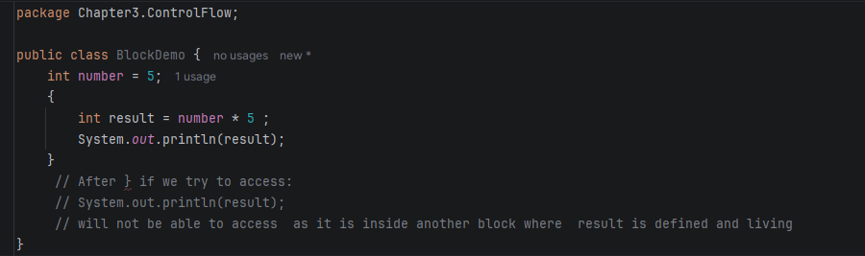

A nested block: is a block created inside another block. Each nested block creates its own scope while still being able to access variables declared in the outer block.
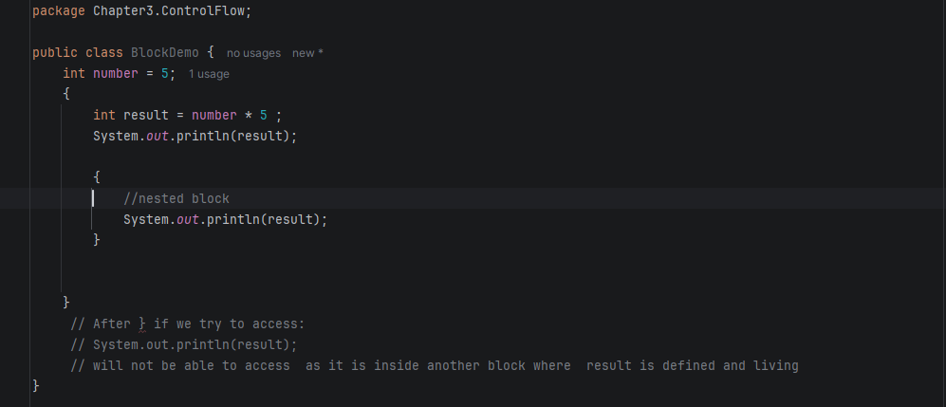
Java follows several rules for variable visibility:
- Variables are accessible only within the block where they are declared.
- Inner (nested) blocks can access variables from outer blocks.
- Outer blocks cannot access variables declared inside inner blocks.
- When execution leaves a block, all local variables declared in that block are no longer available.

Java does not allow a local variable to be declared more than once within nested scopes if it has the same name as an existing local variable.
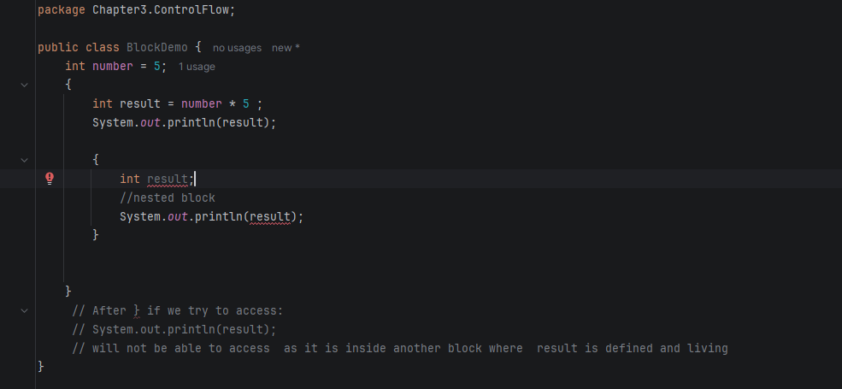
Block scope is an essential concept because it helps programmers:
- Control where variables can be accessed.
- Prevent accidental modification of data.
- Reduce memory usage by removing variables when they are no longer needed.
- Improve code organization and readability.
- Avoid naming conflicts between variables.
- Write modular and maintainable programs.
- Minimize programming errors caused by variable misuse.

view block scope as a way to limit responsibility. A variable should exist only for the task it performs and should not remain accessible after that task is complete. This practice follows the principle of least visibility, where every variable is given the smallest possible scope, making programs safer, easier to understand, and less prone to bugs.

- Conditional Statements
Just as people evaluate situations before taking action, a Java program uses conditional statements to determine what should happen based on specific conditions. Instead of executing every instruction, the program examines a condition and chooses the appropriate path. This ability to make decisions allows software to respond intelligently to different inputs and situations, making conditional statements one of the fundamental building blocks of programming.

conditional statement: is a control structure that allows a program to execute different blocks of code depending on whether a specified condition is true or false.

The if Statement
The if statement is the simplest conditional statement. It executes a block of code only when the specified condition evaluates to true. If the condition is false, the program skips the block and continues with the next statement.

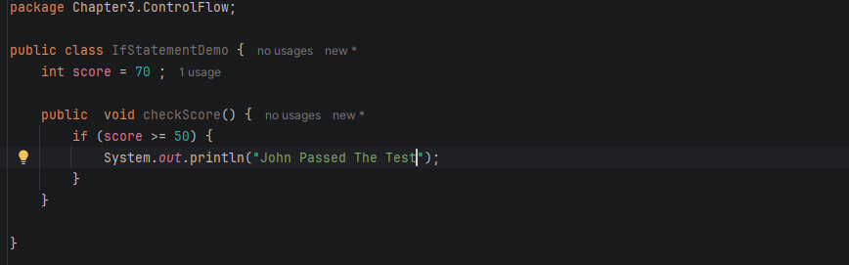

- The condition must return a Boolean value (true or false).
- Parentheses around the condition are mandatory.
- Curly braces {} are recommended even when there is only one statement.
- If the condition is false, the block is skipped.
The if...else Statement
The if...else statement provides two possible execution paths. If the condition is true, the first block executes; otherwise, the else block executes.
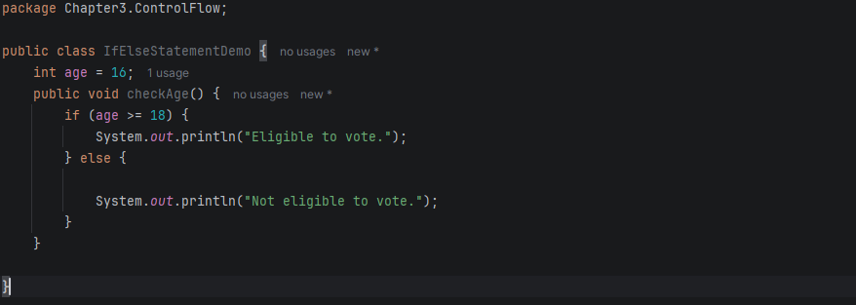

- The else block is optional.
- Exactly one block executes.
- Improves program flexibility by handling both possible outcomes.
The if...else if...else Statement
When multiple conditions need to be evaluated, Java uses the if...else if...else structure. Conditions are checked from top to bottom, and the first condition that evaluates to true is executed. Once a match is found, the remaining conditions are ignored.

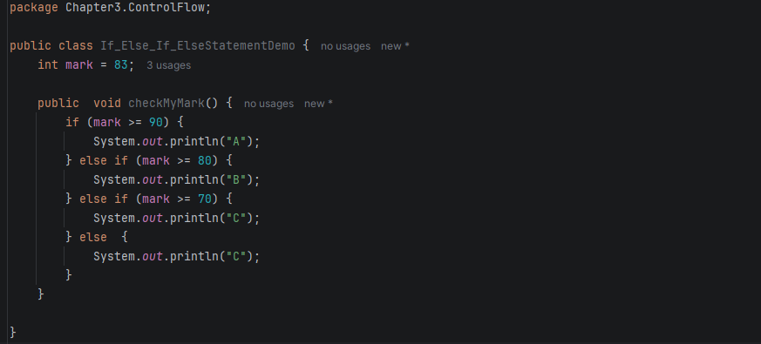
- Conditions are evaluated sequentially from top to bottom.
- Only the first matching condition executes.
- The else block serves as the default case when no conditions are true.
- Arrange conditions from the most specific to the most general.
Nested if Statements
An if statement can be placed inside another if statement. This is called a nested if, allowing more detailed decision-making.
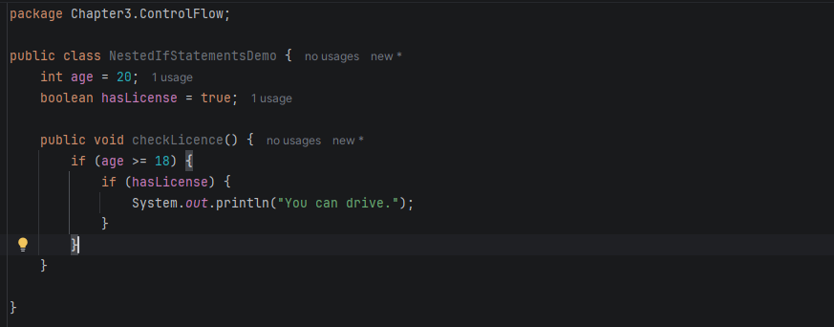
When an else appears without braces, Java automatically associates it with the nearest unmatched if

- Loops
A loop is a control structure that repeatedly executes a block of code as long as a specified condition remains true.
Loops help programmers automate repetitive operations without duplicating code.
Java provides several looping structures, including:
- while loop
- do...while loop
- for loop
The while Loop
The while loop repeatedly executes a statement or block of statements as long as the specified condition evaluates to true.
The condition is evaluated before each iteration. Therefore, if the condition is initially false, the loop body is never executed.
- Evaluate the condition.
- If the condition is true, execute the loop body.
- Return to the condition.
- Repeat until the condition becomes false.
- Continue executing the remaining program.
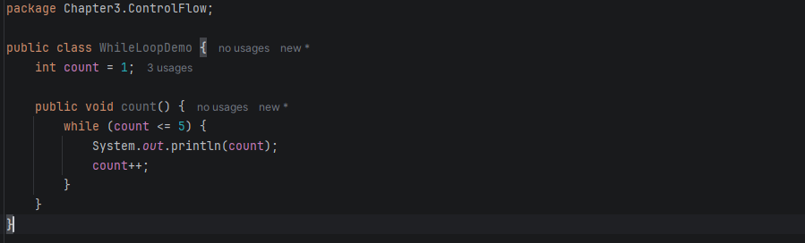
The do...while Loop
The do...while loop executes the loop body first and checks the condition after execution.
Because the condition is evaluated at the end, the loop body always executes at least once, regardless of the condition.
How the do...while Loop Works
- Execute the loop body.
- Evaluate the condition.
- If the condition is true, repeat the loop.
- If the condition is false, exit the loop.

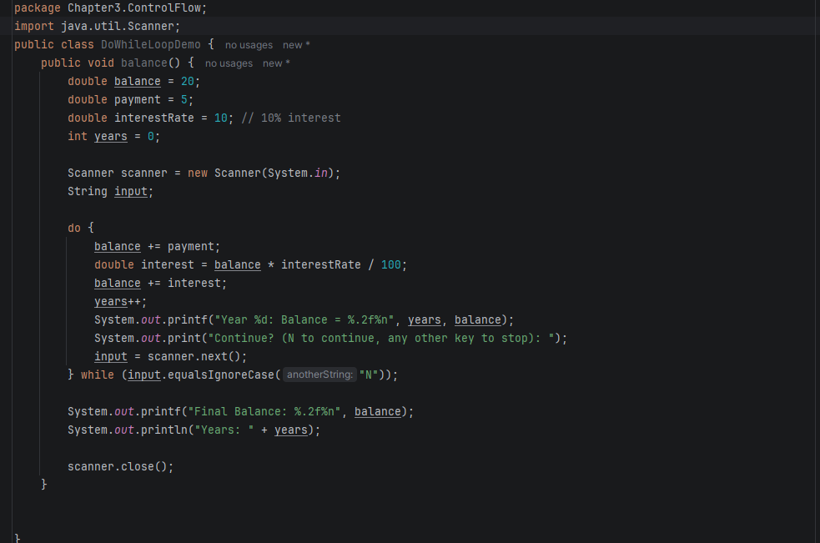
- The loop body executes at least once.
- The condition is checked after execution.
- Useful when the first execution must always occur.
- Commonly used in menu-driven and input validation programs.

- Determinate Loops
A determinate loop is a loop in which the number of iterations is known or can be determined before execution begins.
In Java, determinate loops are commonly implemented using the for loop, which is ideal for counter-controlled repetition.
The for Loop
he for loop repeatedly executes a block of code while a specified condition remains true. It is primarily used when the program knows how many times a task should be repeated.
Unlike the while loop, the for loop combines the three essential parts of iteration into one statement:
- Initialization
- Condition
- Update

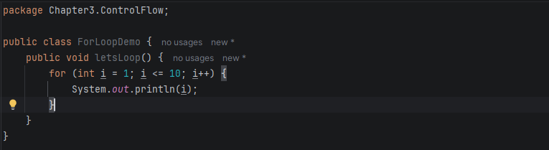
How the for Loop Works
The execution order is:
- Execute the initialization once.
- Check the condition.
- Execute the loop body if the condition is true.
- Execute the update expression.
- Repeat from Step 2.

- Multiple Selections with switch
A switch is a multi-way selection structure that evaluates a single expression and executes the block of code associated with the matching case.
Instead of writing multiple if...else if statements, switch provides a cleaner and more organized way to select one action from many alternatives.
Why Use switch?
Use a switch statement when:
- Comparing one variable against many possible values.
- Building menu-driven applications.
- Processing user commands.
- Handling different states or options.
- Improving readability compared to long if...else if chains.

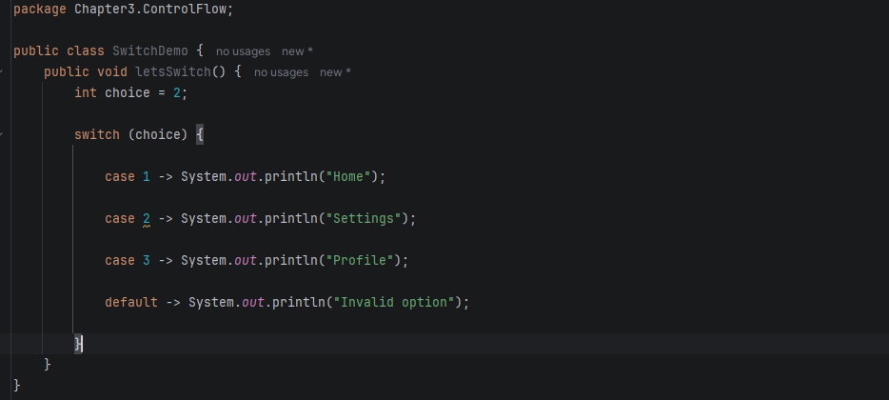
- Statements That Break Control Flow
The break statement immediately terminates the current switch case or loop.
Without break, execution continues into the next case. This behavior is known as fall-through.

Switch Expressions
A switch expression returns a value instead of simply executing statements.

The break Statement
The break statement immediately exits the nearest loop or switch statement.

Labeled break
A labeled break exits multiple nested loops at once.

The continue Statement
The continue statement skips the remaining statements in the current iteration and immediately starts the next iteration of the loop.

think of switch as a decision table rather than a series of conditions. They use it when one variable determines multiple possible outcomes because it is clearer, easier to extend, and less error-prone than long if...else if chains. Modern Java developers generally prefer the arrow (->) syntax and switch expressions since they eliminate accidental fall-through and produce more predictable code. They also use break and continue sparingly only when these statements simplify the logic because excessive use can make the program's flow harder to follow. The goal is to keep control flow structured, readable, and easy to maintain.

